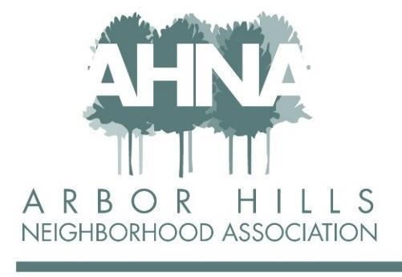
BOARD MEETING
Tuesday May 10, 2022
Licari’s Bar & Grill - our first in-person meeting in 2+ years!
If you are unable to attend, please email Ashley at akgibson17@gmail.com
Meeting starts at 6:30 pm

Attendees: Ashley Gibson, Mary Sara, Jackie Cooper, Aaron Eicher, Nanci Horn
Approved absences: Rebecca Koerschner, George Ermert, Nicholas Griffiths, Grant Roeming, Josh Grotheer, Lisa Fernandez, Michael Horecki

NO QUORUM - NOT ENOUGH ATTENDEES

- Approval of March Meeting Minutes & Review Follow Ups - Rebecca 6:30
- Not present

- Neighborhood Engagement - Lisa 6:35
- Not present

- Membership Update - Jackie 6:45
- Not enough envelopes printed, short ~100 to stuff inside newsletters
- 116 members, ~1/3 paid online, 25 new members from 2021
- Ashley: has not met with George; last year’s non renewals – emailed and asked if they were renewing; recommend to do the same with the 82 non-renewals
- What is the benefit of membership?
- Welcome packet needs to be updated (very outdated!) Jackie will reach out to Nicholas to make updates (see Google doc and email from January);
  - ACTION ITEM Nanci will talk to Nicholas re in-person event for block captains

  - 2022 Membership Total
  - 2023 Membership Dues
    - Increase dues? Been $20 since the 1980s
    - Do not have funds to do much more than print newsletter and current event options

- Budget - Mary 6:55
- Newsletter ~72% of budget: Design cost $360; would need to pay this fee for next three newsletters (NO BUDGET for this); Nanci offered to put articles into a software program to format
  - Shorter newsletter? Print one (summer), include envelopes, remaining 3 online?
  - Already have commitments to advertisers in printed newsletter
  - Add helper lists (kids – snow shoveling, babysitting, dogwalkers, raking leaves, etc); not online for safety (would have to be stuffed in newsletter)
  - Need a more financially sustainable way for the newsletter
  - Nanci: can we go to only 3 printed newsletters (Jackie – only budget for 1 more printed newsletter at current costs); have we looked at online printing options?
  - Ashley will talk to Michael about newsletter budget (will include Josh because of advertising partnerships)
- Receiving checks from advertisers – should Mary send a Thank You letter? (Is Josh doing this already?)
- Sign printing: Food Truck signs were ~$53; budget for signs is $150
- Website: next payment is in the fall – need to decide if we continue with same site/provider (Ashley will plan discussion for July meeting)

- Events - Nanci & Aaron 7:10
- Spring cleanup, about 22 people attended; provided sandwiches using Events budget
- Neighbors asking when Garage Sale is being held; last year posted to Facebook and NextDoor and in newsletter; not listed under events in recent (Summer 2022) newsletter
  - previously people registered their house and there was a sheet of paper with map and list of addresses at signs at neighborhood entrances; Nanci suggested putting a QR Code with information on sign [most likely NOT happening this year?]
- Have an Events committee with two other neighbors who were at spring cleaning event and wanted to do more!
  - Upcoming events, Food Truck vendors
    - Want variety at each event (May: JD’s, Jakara, Mama Meg’s Ice Cream)
    - Aaron has had 4 trucks contact him recently
    - Nanci looking at pasta and Hawaiian poke trucks
- Promoting membership at events
  - Aaron will print membership forms and bring table/chairs (Jackie will print out current membership list); Aaron will get Square from Neil for CC payments
- 4th of July: 3-5pm in newsletter; traditionally had been held in the morning (10-12); Food? Face painting? Cool cars? Other? Nanci will create Facebook event; Jackie will create what the map used to be and send to Nanci and Aaron (in Google drive)

- Newsletter - Michael 7:30
- Not present
  - Content for summer newsletter
  - Cost per edition

- Annual Meeting & Elections 7:40
- Traditionally in-person at Arbor Covenant Church; entire neighborhood invited; usually ~30-40 attendees
- October for next meeting – plan for an in-person event at Arbor Covenant on a Tuesday night (masks?)
  - Ashley will ask residents with teenage children if they would babysit (for free?)
  - 2nd Tuesday of the month (6:30pm – 8pm)
  - Ashley will contact Pastor at Arbor Covenant for date/time
  - Agenda will be discussed at July meeting

  - In person, hybrid, or virtual?
  - If in person, location?
  - Date/time?
  - Positions up for election:
    - President
    - Communications Coordinator
    - Membership Coordinator
    - Newsletter Editor
    - Member at Large (Josh’s role)
- Current people in roles need to let Ashley know if they will run again

- Adjourn 8:00
Notes submitted by Jackie Cooper

