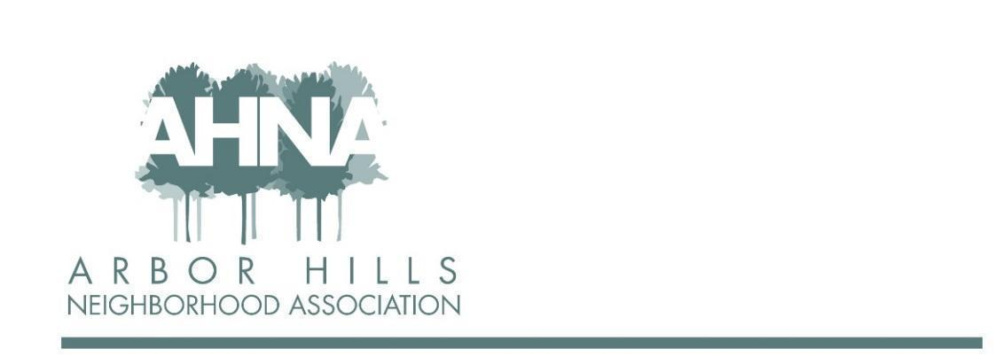
BOARD MEETING
Tuesday, January 11, 2022
Zoom

In attendance: Ashley Gibson, Lisa Fernandez, Grant Roeming, Mary Loch-Sara, Aaron Eiker, Josh Grotheer, Nanci Horn, Michael Horeck, Nicholas Griffiths, Jackie Cooper, Neil Dinndorf

Absent (excused): George Ermert, Rebecca Koerschner

- Introductions - All 6:30

- Guest speaker: Jake Blasczyk (Dudgeon Monroe NA - water project) 6:45
Co-chair of the PATH committee, take care of prairies that run through DM neighborhood in partnership with the other neighborhoods. WATER (Water action to encourage responsibility) (UW Arboretum) - to look at stormwater issues. Arbor Hills is in the Lake Wingra watershed. Look to neighbors for water stewardship (rain gardens, rain barrels, etc.). Would like Arbor Hills neighbors to participate in the May 21, 2022 Vilas Park Event (1pm-4pm) (send a team, assist with publicity, feature practices that are in place in Arbor Hills, etc.). Would also like associations to sponsor by making a financial contribution if possible (small grant they received doesn’t cover much). Presence at event is equally, if not more, important. Family-focused, different presentations (speakers, tables), kids events, and more.

- Guest speaker: District 10 Alder Yannette Figueroa Cole 6:52
(not in attendance)

- Approval of November meeting minutes & follow-ups - Jackie 6:53
Motion to approve: Michael, 2nd Ashley
Action items (from September and November Meetings):
  - Replace signs for Food Truck night; Ashley recommends additional signs for Halloween Night, etc. [Ashley and Neil are planning to order new signs; order has been canceled twice; will get done in 2022 (Nanci, Aaron, Ashley had a discussion and will work on this closer to first event)]
  - Reorder envelopes for membership [Michael working on the formatting to get quote from printer; still in process]
  - Membership list - working on this (Jackie); Nicholas - could get emails from block captains, will send to Jackie to add; Jackie recommended sending a “welcome to the list” email and making sure people know they can unsubscribe (in progress)
  - Under budget on ad revenue, only rec’d from MG&E (Neil will follow up with Josh) [Neil - another has come in, still need to follow up with Josh - no update]
  - Question from George - grants; our income is not reflective of what we used to have due to an increase in events and does not allow for grants; what can we do? Neil - can we get someone to sponsor events (ex. 4th of July party); Jackie asked about membership levels, George wonders if we increase dues since we have been at $20 for a long time; Nicholas - think a membership push to get more members vs. increasing the membership fee, have “booths” at our events to get more members; Ashley - membership “value”, for example higher member level gets paper copy of newsletter
    - sub committee to look into this (membership in more detail and come back to board with recommendation (before/early 2022) [Mary as Treasurer, Jackie membership list, George - will lead, Nicholas] [Neil will check on numbers of autorenewals and report to sub group; add to invite for first meeting] (update later in meeting)
  - One large packet of newsletters (90-100) have not been picked up/delivered
    - Communication committee should meet to discuss this bottleneck and communication going forward
      - communication committee meeting: Michael will lead, Rebecca, Ashley, Lisa

- President’s Report - Ashley 6:57
As of 1/1/2022 Yannette Figueroa Cole is new Arbor Hills Alder (aka District 10). Ashley met with Yannette to talk about Arbor Hills. Sheri Carter is still District 14 Alder. With the redistricting, three (3) current alders live in District 10.

New password set for 2022 for the Google Drive for the board members.

Met with MPD Captain Mike Hanson (1/4/2022) - more time/resources in the winter so looking for ideas. Ashley mentioned traffic enforcement on the Frontage road as well as on Grandview. Let Ashley know if you have other suggestions/ideas.

Board member changes: Jackie will move to serve as Membership Coordinator (taking over some responsibilities that Neil as Treasurer had been doing in an effort to retain and attract members). Rebecca will be the Communication Coordinator and will absorb the Recording Secretary duties (i.e. taking notes at meetings). Will need to update bylaws at the annual meeting.

Email spam from “Ashley” - check the “from” email address. If it is not Ashley’s email, just delete. In an effort to hopefully reduce these emails, any board member email addresses will be removed from the website and only the Arbor Hills email will be visible.

Board member contact information updated - Ashley will share with everyone.

- Budget - Neil 7:14
Membership and financials will be separated, with Jackie and Mary taking over those aspects. 2021 members = 172 (173 with last minute renewal) out of 587 households (includes the 3 non-comp members - Steila Stubbs, Bradley Hutter, Richard Kilmer - but there is a new one for our district; Ashley sends digital versions of the newsletters to these contacts; no other “benefits”; good reminder to reassess/reengage). Potential for more and hopefully with a dedicated membership chair it will be easier (ex. in 2012 there were 279 members). Checking balance $501.53, Savings balance $7,724.68. (Lisa: did we contact non-renewals to find out why? Sent emails, postcards, some dedicated reach out - no negative feedback received. Aaron: are block captains encouraged to reach out to neighbors? Nicholas: not something they really are charged with doing, but they were encouraged to do so.)

Budget: Exceeded membership income because of additional contributions from members. Advertising revenue short $60 from budget, but total income above budget. Operations and Membership Support expenses were below budgeted amount, however we are tracking PayPal fees as we see more people paying online (~$1.12 per $20 membership donation). Communication & Marketing also below budgeted amount. Events expenses were over budget due to the 4th of July Picnic, but we ended the year up $796.67, mainly because we did not pay for a 4th newsletter printing.

Proposed 2022 Budget:
- Income:
  - 175 members ($3,850.00)
  - Increased advertising to $1,500
  - Total budget income = $5,360.00.
- Expenses
  - Basic Expenses: added Zoom subscription and the printing of new yard signs for events.
  - Membership Support Expenses: membership mailing, welcome packets, envelopes - totalling $500.00.
  - Communication & Marketing Expenses: newsletter printing, Website = $2,825.
  - Events budget: $965.00.

- Holiday Lights Contest Results - Josh 7:34
Unanimous winner - Neil & Lisa Dinndorf on Westview Lane! MG&E December Electrical payment prize for the winner has been paid anonymously. Photos will be sent to Michael, including those who received Honorable Mentions. Josh will notify the runners-up that they won and write a blurb that Michael & Rebecca can include in communication.

- Newsletter schedule & recap of committee conversation - Michael 7:38
Subcommittee met to discuss the future of the newsletter.
- As is: $2500/yr; strong communication tool; distribution is a challenge and cost is significant [no email opt-in so easy]
- Digital only: $0/yr; low cost & no distribution; requires engagement from readers
- Hybrid model: $625/run; some distribution but less than current; complication distribution
- 1pg Monthly: $1200/yr; more frequent communication but less robust; more frequent distribution required

Committee decided it was best to continue with the 8-page printed newsletter for now. Challenges in current form: production (making, printing, etc.) and distribution. Schedule locked in for 2022. More organized for advertisers as well. Brainstormed for how best to get distributed through the block captain channel (will work with Nicholas re ideas brought to table). [Mary: membership push in December so that everyone renews in January? Most organizations have a renewal time period. Nicholas - everyone gets a newsletter, member or not. Ashley - last year we did a mailer and will do again this year (lead by George and Jackie). Michael - the newsletter is just one tool for membership. Ashley - put remittance envelopes in December 2022 newsletter for 2023 membership. [Michael is checking to see if Mary’s address is listed for membership payments.] Jackie - no benefits for members, maybe look at B&W cost of newsletter to reduce costs. Nicholas - plan looks good, should have better distribution plan for winter and future newsletters. Ashley - looking at future action plan for some “missed” neighbors to get them involved in events. Nanci - color on front/back with B&W in middle? Michael will look into the cost.

ACTION ITEM: Question - which logo is current/correct (or just two versions)?

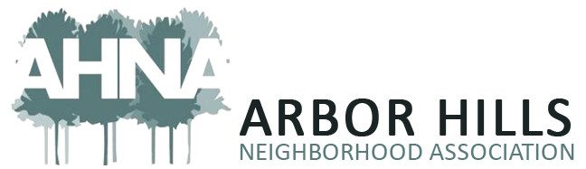

- 2022 Events - Aaron & Nanci 7:55
Met with Ashley and others for hand off. Great engagement this past year with events, so plan is to move forward with same events. Goal is to have a “members only” event to provide members with a benefit. Work within the budget as well. [Ashley - once calendar is finalized Rebecca will be able to schedule communication well in advance.] Nanci is looking for block captains and others to have remittance envelopes and annual calendars, etc. (Michael working on design, with Mary’s address for mailing; Michael shared what current remittance envelopes look like in the chat.)

- Grants/Community Service Planning - Ashley/All 8:01
Would like to have a conversation about whether and/or how we give grants. Nanci, Aaron, Mary, Lisa interested. ACTION ITEM: Ashley will send an email to this smaller interested group.

- Adjourn 8:03

