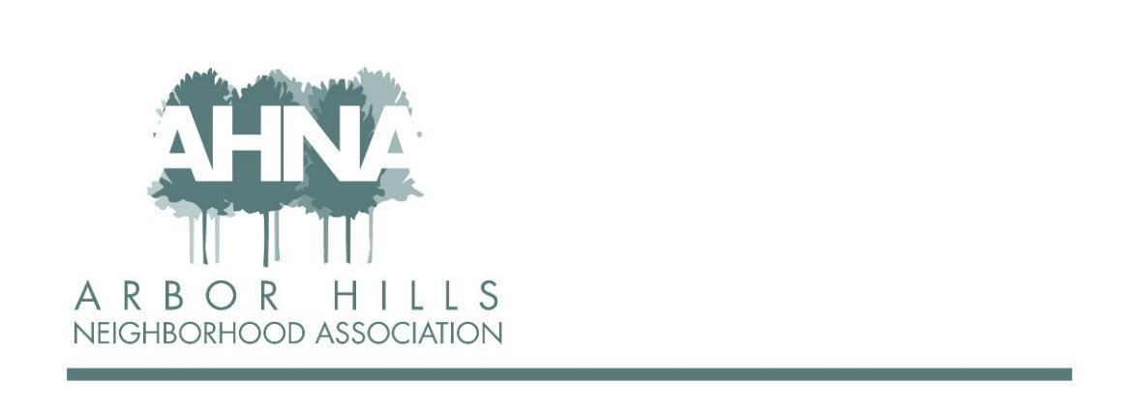
ANNUAL MEETING
Tuesday, October 12, 2021
Meeting starts at 6:30 pm

- President’s Report & Vote on Updates to Bylaws - Ashley Gibson 6:30
Moved to Arbor Hills in 2018, rented first before purchasing. Saw the neighborhood newsletter on the counter of the house they toured - and saw the association was looking for a newsletter editor (joined the association and applied for this role). July 2021 expanded family with the birth of son Arthur. Had planned block party on day baby Arthur was born, and the neighbors continued with the celebration (and left chalk drawings welcoming Arthur home). Goal as president is to create a sense of community for everyone in the neighborhood.

Strengths and Opportunities
- Creating a welcoming community / how to better engage new residents
- Building a robust & diverse membership / just short of 2021 goal
- Hosting events to provide opportunities to connect / looking for new and creative ways to connect (Looking for a new Events Coordinator!)
- Strong network of block captains / find add’l ways to welcome new neighbors
- Communication to keep neighbors in the loop / paper vs. digital newsletters, engaging neighbors who do not use email
- Balanced budget / goal is to continue this!

Other ongoing issues for neighborhood:
- Redistricting process - proposes to move Arbor Hills OUT of district 14 (public comments still open)
- Adsorption of the Town of Madison

- Report from Alder Sheri Carter 6:45
- Currently working on operating budget ($358M) - will send out link with more information; lots of cuts (parking meters did not charge fees in 2020, hotel taxes/fees did not meet goal; used funds to help with rent assistance and public health due to COVID-19)
- Town of Madison:
  - Wells, septic tanks, lack of sidewalks, calverts, etc. for homes, etc. in Town of Madison
  - Mobile home issues due to building inspections, looking to help with these costs
  - Fire Dept took over Town of Madison in Nov 2020, working on parks, etc.
  - Question: what will happen to Town of Madison Town Hall (in negotiations with Fitchburg), Fire Station 6 (going through renovation, Madison will lease this space for 1-year for $0)
- Redistricting: proposed map will be voted on November 2
  - District 14:
    - Leopold neighborhood would stay in District 14, as would River Bend
    - Arbor Hills would move to District 10 (Allied, Meadowood, Nakoma, part of Midvale area)
      - Arbor Hills has been part of District 14 for 50 years, Sheri asked to remain in District 14 but the committee did NOT agree.
      - Four things used to make decisions, two being Communities of Color and another being natural borders (streets/lakes), as well as number of people in each district
      - Town of Madison absorption put Arbor Hills well over the ideal number of people
      - Meadowood Alder believes it is a heavy lift for District 10; Arbor Hills and the other neighborhoods have large differences for an alder to manage, etc.
      - “Lost City” (built on wetlands) also in discussion
    - Will share links, etc. with neighborhood via all the communication channels (feel free to contact Sheri with questions at any time)

- Treasurer’s Report & Vote on ‘21-’22 Budget - Neil Dinndorf 7:02
- Concluding 6th year as Treasurer
- 2021 Financials:
  - Current membership = 172 (goal was 175)
  - Exceeded income expectations (more in donations), ad partners (thank you to Josh G!)
  - Expense summary: budget $4700, expect ~$4800; largest expense by far is the newsletter (50% of the budget, ~$2400/year)
  - Net income expected +$620
  - Cash balances = $8,852.37
- Proposed budget for 2022:
  - Membership: 175
  - Income budget planned $5,360
    - Member dues + donations = $3,800
    - Ad partners = $1,500
  - Expense budget $5,360
    - Operations = $1,070
    - Membership support = $500
    - Communication/Marketing = $2,825
    - Events = $965
  - Motion to accept budget: George Ermert, Nicholas Griffiths 2nd
  - Election poll to vote: 20 yes, 0 no; budget passes

- Report from South Madison Police Captain Mike Hanson 7:13
- Been in South district since 2019
- Data from Captain’s Quarterly
  - Shots fired incidents Todd Drive/Churchill area, Beld St. area
  - Arbor Hills was been a “Steady Blue” test area: burglaries down; no robberies reported; “shots fired” down [in comparison to 2020] - test is over, but appears that it was a successful test, at least in the Arbor Hills area; dedicated detective for Domestics to work with victims
- Major Calls for Service
  - Late July fatal motorcycle crash on W. Beltline frontage road (result of reckless driving; many resources deployed with speed lasers, found many drivers speeding; on project list going forward)
  - Labor day homicide at Penn Park (suspect still on the loose)
  - Kayser Ford burglaries among others (individual wanted on several warrants, arrested in Sauk County)
- Types of calls for service (30 days)
  - Check property (113); traffic (83); check person (81); 911 Call - unintentional (60); etc.
- Shots fired YTD (data from 2 weeks ago)
  - 169 incidents, City-wide
- Strategic plan:
  - Most district crime numbers down since 2020
    - Youth gun violence
  - Domestics (repeated) down from 100 to 61
    - South PD emphasis is connecting with the victim, offering resources, arresting suspect quickly
  - Use of “Steady Blue”
- Toured Town of Madison areas with Chief that will be part of City of Madison from a Madison Police perspective; 8 officers dedicated to Town merger as part of South District
- Questions: none
- Comments: Thank you to Officer Devlin for attending some of our events (Food Truck nights)

- Recap of 2021 Board Activity 7:26
  - Events - Samantha Castro [interesting year after 2020 and no events; successful event year; food truck nights were a challenge due to other neighborhoods also wanting trucks and loss of organization that oversaw food trucks; great 4th of July event with Madison Ladder 6; looking forward to last event of year - Halloween parade and park event with “Trunk or Treat” event at park; stepping down after 6 years and looking for NEW Event Coordinator! Will stay on to help transition for next person - let us know if you know of a neighbor who would be interested]
  - Block Captains - Nicholas Griffiths [hopefully everyone is aware of who their block captain is - map is on the website, with names and contact info for each block captain; these are the people who deliver our quarterly newsletters and welcoming new residents to the neighborhood; get out and meet and engage with your block captain; looking for Block Captain for Grandview Blvd 2808-2831]
  - Communications - Michael Horecki (newsletters: all volunteer team; 4/year; areas of coverage: experts among us, Madison City/Town merger, pandemic coverage; 2022: 4 editions per year? Continue printing and full neighborhood distribution?] & Rebecca Koerschner [summary of survey sent out earlier this year: average time in neighborhood just over 20 years; largest issue to focus on is communicating important news affecting the neighborhood; ~60% asked about volunteer opportunities; Communication channels: AHNA Facebook page, AHNA email list, also posting unofficially on NextDoor, website (City of Madison events & news, volunteer opportunities, etc.)]

- Master Recycling Program Overview: Jackie Bastyr-Cooper 7:38
Look for information in upcoming newsletters (7 Rs of Waste and more!)

- Presentation of Board Candidates 7:41
- Vice President: George Ermert (has lived in neighborhood since 2013; been on board since 2015)
- Treasurer: Mary Sara (has lived in neighborhood for 32 years; was VP and newsletter editor in the past when kids were little; advocate for neighborhoods, grew up in strong neighborhood in Minneapolis and Arbor Hills reminds her of that neighborhood; has served as treasurer in other groups in Madison; was on County Board for 2 years; started Tree board; started adult bookstore ordinance to allow them to be more accepted in neighborhoods; loves music, played in the park during food truck event; loves walking dog through neighborhood)
- Member at Large: Lisa Fernandez (has lived in neighborhood for 8 years; particularly interested in social justice and anti racism issues; hoping to form an anti racism committee; wants to be more involved in the neighborhood and to give back)
- Events Coordinator: OPEN

- Election of Board Members 7:45
- Motion to approve all candidates: Dave, 2nd Bob
- Poll to vote: 21 yes, 0 no; election to board passes

- Bylaw changes proposed
- Prioritizing mission to build & foster inclusion by hosting events
- Make the option of virtual meetings more explicit
- Revision election/nomination process
- Clarify that as a 501c3 organization we cannot endorse political candidates
- Motion to approve bylaw changes: Mary, 2nd Samantha
- COMMENTS/QUESTIONS: Bob - because of newsletter expense, would it be worthwhile to increase membership dues from $20 to $25? (Ashley - board is already talking about this; we recognize the benefits of a printed; will not take lightly any changes; this will not affect bylaws)
- Poll to vote: 23 yes, 0 no; changes to bylaws passes

- Q&A 7:52
- Helpers List (kids that did raking, dog walking, etc.)? Was in the newsletter in the past (with contact information); NextDoor and other electronic media not good from a safety issue
  - If there are kids interested, something we can talk about (fyi: newsletter is posted on-line)
- How is the cash balance determined - any plans to donate excess? (Neil - no plan for a specific dollar value as a cash balance; ideally like to have a balance to cover one year of expenses in case of unexpected events)

- Adjourn 8:00
Meeting Recording:
https://us02web.zoom.us/rec/share/AMSMMF4Bova4ZXDP8toa161EKnBX63QWQy7qhiggPnlKrIgnJp-npJ4lPTEih5pL.O80fa29YhnH1-Yij
Access Passcode: eJvi@7=#

