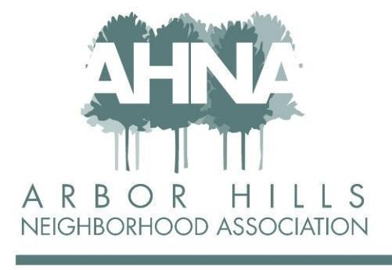
BOARD MEETING
Tuesday September 13, 2022
Licari’s Bar & Grill

Attendees: Ashley Gibson, Mary Sara, Jackie Cooper, Aaron Eicher, Nanci Horn, Rebecca Koerschner, Grant Roeming, Josh Grotheer, Lisa Fernandez, Michael Horecki

Approved absences: Nicholas Griffiths
Unapproved absences: George Ermert

- Approval of July Meeting Minutes - Rebecca 6:40
  - Mary motions for approval
  - Aaron seconded
  - Minutes approved

- Proposed 2023 Budget - Mary 6:50
  - Additional member contributions (above and beyond dues) went up by $325 this year compared to 2021. Kudos to Jackie for all her work here.
  - Short $540 on ad-revenue for 2022 compared to budget
    - MG&E, Arbor, Steve Pschorr
    - Proposal for next year to have these folks pay in Q1
    - Per Josh, we’re expecting $990 by EOY (due to new advertisers)
  - Discussed proposed budgets for each category, and lines for removal
    - Link to working budget
    - Removing the zoom expense - will meet in person or use personal Zoom accounts for meetings
    - Removing the neighborhood improvements line - instead, wait until we have a specific project in mind and budget for that
    - Newsletter printing - sourcing new quotes for printing
    - New line item for a block party, how to allocate these dollars to be discussed by the board in the future
    - To keep the budget balanced keeping the membership goal at 175, and bring down advertising revenues
  - Will review the proposed budget at the annual meeting and will go for a membership vote

- Website Management - Jackie, Ashley 7:10
  - Now back to our hosting website on Wix (maintained by Ean)
    - Everyone go check it out
    - Still working on the domain and email transfer
  - Members now have the ability to pay different amounts (20, 30, 50), or to set up a recurring membership
  - Would like to do some training so that everyone can control their own section of the website if they would like that autonomy
    - Mary expressed concerns about how this will put up roadblocks for our older neighbors to be involved
      - Ashley noted that website training will be voluntary, not required
    - Ean can continue to update sections for board members
- Sleep in heavenly Peace Event - Mary 7:15
  - Build beds volunteer opportunity on 9/20
  - Rebecca to send out an email communication to the membership
- Annual Meeting Planning & Elections - Lisa, Josh, Ashley 7:20
  - Agenda is drafted. Location is confirmed: Arbor Covenant. Starts 630p on October 11. Childcare will be provided in the front left room.
  - Up to 30 mins of discussion and Q&A
  - 2023-2024 Terms. Reviewed who is running for re-election, and where we have open positions
    - Information will be printed in the newsletter
  - We are in need of a newsletter editor - think of folks who we know in the neighborhood that might be a good fit as this is a very important role.
    - Last edition that Michael will do is the Jan published newsletter
    - New board member will then be responsible for the one published end of Q1
  - We will also have an open position for a board member at large - a good introductory position
- Newsletter Costs/Future Planning - All 7:30
  - We have budgeted to stay the course with the cost of the newsletter
    - May be black&white or color just depending on cost
  - Mary: Would like to mail newsletters instead of current distribution strategy (this would require paying for postage and manually stuffing envelopes. Would like to limit distribution only to paying members.
  - Lisa: things we can do to improve getting it out - proposal to keep current format but adjust distribution strategy
  - Josh: needs to go to everyone b/c advertisers pay for that (and the extras get passed out to the advertisers).
  - Micheal: doesn't start with cost, starts with mission and values. The newsletter is one of the things people value most.
  - Nancy: could be done in a smaller format, but then there isn’t room for adds
  - Grant: thinks its great
  - Rebecca : everyone should get it, does it need to be quite as long?
  - Ashley: everyone should get it. Would introduce new logistical challenges for block captains to make sure they are sending it out to the right people if we went the route of only sending to members.We are getting quotes on B&W vs color.
  - Consensus that we will continue to distribute the newsletter to all residents and that we won’t talk about this again this year
- Events
Shout out to Nanci & Aaron for doing an awesome job on the last food cart night! The music was awesome and people loved it!
- Adjourn 7:45
  - Michael motions to adjourn
  - Josh seconds to adjourn
  - Meeting Adjourned

