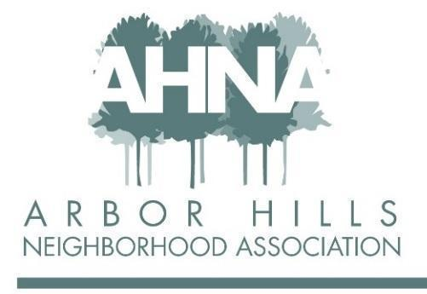

BOARD MEETING – Tuesday, September 12, 2023
Panera Bread, 2960 Cahill Main, Madison, WI 53711

Attendees: Jackie Bastyr-Cooper, Sheri Carter, Lisa Fernandez, Erica Fletcher, Chuck Friedrichs, Ashley Gibson, Josh Grotheer, Nanci Horn, Cathy Means, Mary Sara, Linda Szabo

Approved Absence: Aaron Eicher

Prior to the approval of the August Meeting Minutes, Linda mentioned that the newsletter article from the Garden Committee is “all lined up.” Also, her house on Todd Drive is for sale!

- Approval of August Meeting Minutes

Lisa: First motion to approve the minutes
Linda: Second motion to approve the minutes

- Event Planning: Nanci/Aaron

  - Workout in the Park: August 26

Two people attended. (Low attendance may be due to the event not making it into the last newsletter.)

  - Food Truck & Music in the Park: September 21, 5:00-7:00 pm

An email has been sent to Taco Gato to confirm they will be in attendance. Aloha Wagon is scheduled to come.

Action Items:
    - Aaron has the signs and will put them out on Sunday/Monday the week of September 17.
    - Aaron is still trying to find a musician.

  - Halloween Bike Parade & Party in the Park (corner of Grandview Boulevard and Kingston Drive): October 29, 3:00-4:00 pm

Action Items:
    - Aaron will purchase food (hot dogs, brats, chips, etc.) for the cookout, and candy for the trunk or treaters. We should have plenty of paper plates, etc. Aaron will also bring the grill on Sunday and set-up the food station before the parade.
    - Anyone participating in the trunk or treat should meet at the park at the beginning of the parade.
    - If you would like to prepare something and bring it to the cookout, that would be great!
    - Volunteers are needed for the following:
- Lead the parade; this typically follows the same route as independence day
- Hand out candy to the trunk or treaters
- Help with setting up the food station
- Help with passing out baby pumpkins for decorating
    - Erica will contact Leopold for volunteers (through their newsletter).
    - Ashley will send a message through the Leyton Lane email list for volunteers.
    - Chuck will advertise the event and need for volunteers.

Since this is our last big event of the year, please talk to your neighbors and encourage them to participate.

  - Magnet: Josh

Josh presented an example of a magnet to advertise upcoming events. They can be included with upcoming newsletter issues. The cost would be under $400 for 600 magnets. Ashley believes this is a winner!

Action Item: Josh to start work on developing/ordering the magnets.

- Finish Reviewing Proposed Bylaw Updates: All

Continued the discussion starting with Bylaw 4(c).

Bylaw 4

Action Items:

- Under e) ii) (d) Erica, Josh, and Mary to review
- Ashley: Under e) ii) (d) – move this to the Finance Section

Mary: First motion to approve Bylaw 4
Linda: Second motion to approve Bylaw 4

Bylaw 5

Action Item:

- Under c) i) remove the following wording . . . and membership nonresident owner of real estate . . .

Mary: First motion to approve Bylaw 5
Josh: Second motion to approve Bylaw 5

Bylaw 6

Action Item:

- Under a) i) (d) change $1,000 to $700

Chuck: First motion to approve Bylaw 6
Lisa: Second motion to approve Bylaw 6

- Budget Review: Mary

Mary presented the updated budget. As of August 31, 2023, there is a Business Checking Account Balance of $5193.83, and a Savings Balance of $7,839.38. Each line item of the budget was reviewed by the Board and adjustments were made.

Action Item: Mary will make the budget changes/adjustments discussed during the meeting and will send out via email for comments before the Annual Meeting.

- Annual Meeting Planning: Josh

Josh reviewed the “Board Member Elections at the Annual Meeting” sheet.

- Adjourn
Nanci: First motion to adjourn the meeting
Linda: Second motion to adjourn the meeting

