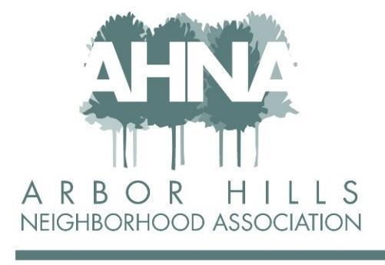
BOARD MEETING
Tuesday July 12, 2022
Licari’s Bar & Grill

Attendees: Ashley Gibson, Josh Grotheer, Nanci Horn, George Ermert, Michael Horecki, Nicholas Griffiths, Lisa Fernandez
Approved absences: Mary Sara, Jackie Cooper, Rebecca Koerschner
Absent: Aaron Eicher, Grant Roeming

- May Meeting Minutes:
- Josh Motions To Approve
- Nancy Second
- Board Approves By Unanimous Voice Vote.

- Budget:
- Advertising revenue is a bit under, but this is due to folks not paying yet. So, we are expecting to exceed last year’s ad revenue once it is all counted
- JRs Mulch is falling off in the next two quarters and will not be advertising
- Hilldale ad from Nancy can take the place of JRs Mulch
  - Nancy & Josh to coordinate Hilldale Ad for Fall Newsletter
- Discussion around the Dec lights reward. Was previously donated, paid out of our budget last year (correction – 2021 lights award was paid from anonymous donor in the neighborhood). Do we want to do a different reward this year since it isn’t donated anymore?
  - Perhaps it is being a judge next year and then also a small giftcard?
- Discussion around charitable giving and what we should do with the extra $$ in the budget. We have ~$10k in savings and yearly expenses of ~$6k.
  - Can we give to organizations?
  - Discussion around a vision of us not being a pass through organization – if we have surplus let’s apply it to our community.
  - Additionally, $10k to $6k sounds like a large surplus, but it is actually not quite as large as that makes it sound. Overages this year + a year of cushion, leave significantly less wiggle room.

- Monthly Membership Report:
- Discussion around when we raise dues?
  - Will pursue with a proposal from Mary at the Sept meeting
  - Driven by data on what we need
  - Present to the full membership body at the Oct meeting
- Discussion around if we send renewal postcards – George notes cost is logged as $420 in budget – believe it was cheaper than that thanks to EDDM (Every Door Direct Mail). We need to double check and verify the costs.
  - George to send costs and info to Jackie on EDDM costs for postcards.

- Website:
- Ashley walks the crew through the decision doc – recommendation to switch back to Wix
- George makes the motion to move back to Wix
- Josh seconds
- Motion passes unanimously
Ashley to contact current web admin and thank her for her service – begin execution of approved transfer

- Events:
- Can we make an events calendar that board members sign up for attending AHNA events, ensuring we have coverage?
  - Yes – Nancy will run point on being a calendar for the next year
- Nancy will check in with Jackie about a membership signup table for events
- George notes that it is better to do a few good events vs. several weaker events, so we should keep that in mind in the future as we plan events

- Block Captains:
- Nicholas summarizes the block captains meeting – it was good but sparsely attended. Covered distribution challenges in apartment and neighborhoods where block captains don’t live
- Ashley reminds the board the AHNA will reimburse $100 to a block party if folks put it on to help build community
- Josh suggests a membership contest with a $250 reward
  - % of paid members on a street would be one prize
  - Highest increase of paid members on a street would be another prize
  - Jackie to investigate if this is something that we can pull forward into 2023. Perhaps introduce it at the annual meeting?
    - Nancy suggests chili cookoff woven into this idea. Perhaps a chili cookoff across the neighborhood

- Newsletter:
- Ashley & Michael talk through the student designer
  - Josh Motions
  - Nancy seconds
  - Unanimous vote approving student designer contract
- Content is discussed
  - Front Page Annual Meeting & Agenda
  - Recap of Alder Meeting
- Michael to send out printing budget spreadsheet for board review
  - Recommendation that there is not a significantly better printing option than the one we are currently utilizing
- Print-o-graph recommended as another potential vendor
  - Michael to investigate if there is a cost savings
- Can we start sending PDFs to members?
  - Rebecca to investigate if we can email out once published
- Warning email to go out to block captains to let them know it is coming
- Michael to send final summer newsletter to AH

- Annual Meeting & Elections:
- Josh walks the crew through the agenda for the meeting
- Are their older kids who can watch kids in the playroom to ensure the business meeting can happen?
  - Nancy check on teens to watch the kids
- Discussion around how dues $$ is being spent since it will most likely come up when the increase is discussed.
- Plan is that the September meeting will be where the details are hashed out so we are ready for the annual meeting and any discussion around why dues are going up

- Neighborhood Engagement:
- Would require 50 extra newsletters to reach out to the apartments in that area
- There is strong diversity in the neighborhood, but we are very segmented
- Do we potentially have someone speak at the annual meeting to share more about the refugees in our neighborhood?

Nancy Motions to Adjourn
Lisa Seconds
Meeting Adjourned
Notes submitted by Michael Horeki

