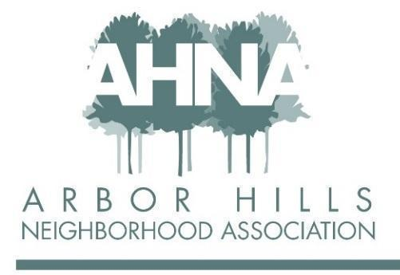
BOARD MEETING - Tuesday June 6, 2023
Licari’s Bar & Grill, 1405 Emil Street, Madison, WI 53713

Attendees: Jackie Bastyr Cooper, Sheri Carter, Aaron Eicher, Lisa Fernandez, Erica Fletcher, Chuck Friedrichs, Ashley Gibson, Josh Grotheer, Cathy Means, Mary Sara, Linda Szabo

Approved Absence: Nanci Horn

Approval of May Meeting Minutes
Jackie: First motion to approve the minutes.
Mary: Second motion to approve the minutes.

Sheri discussed the landscape maintenance of the Post Road Arbor Hills sign. The Garden Club maintains the Frontage Road sign landscaping.

Action Items:
- Chuck: Send email to Ean Gibson the approval of the minutes (in pdf format).
- Mary will contact Bob Alt.
- Charlie Horn will trim near the Post Road sign.

Advertising Update: Aaron and Josh
Action Items:
- Aaron and Josh will meet after the meeting to review the contacts they have.
- Aaron and Josh will reach out to Migrants regarding outstanding payment. Steve Pschorr is paid up through the summer.

Treasurer’s Report: Mary
Mary presented the Minuteman Press estimate for the newsletters, along with the working budget as of May 31, 2023. We are in good shape financially.

$2200 for PayPal fidelity insurance. PayPal, Wix; Sheri suggested Venmo. How members pay: 70% check; 30% online.

Sheri proposed a finance committee. There are currently 3 people handling the money.

Action Items:
- Ashley asked Mary to:
- Draft a bylaw amendment related to audit, and who can go to bank and manage online payments
- Insurance proposal

Membership Report: Jackie
Jackie presented the AHNA Monthly Membership Report.

150 members; 18 new members

Action Item:
- Send letters for renewal.

Block Captains: Lisa
Lisa sent an email to board members regarding the block captains get-together (23 block captains total): June 17, 3:00, Lisa’s house.

Aaron: Use events to get block captains together for meet-and-greet.

The next delivery of newsletter is probably around June 30.

Started discussing CBRF’s; Sheri will look into this.

Action Item:
- Ashley next meeting – Lisa feedback from BC get-together.

Events: Aaron
- Make Music Madison/Food Truck Night, Wednesday June 21
3 bands 3:30-7:00 pm. Food truck and ice cream trucks already booked for 5:00-7:00 pm.
Aaron would like the trucks to start at 3:30 pm. This should be open to other neighborhoods
too.
Action Items:
- Signage: Aaron will look into this and connect with Grant.
- Social media opportunities: Aaron will discuss with Chuck.

- Garage Sale, Saturday June 24
15 people have signed up.
Action Items:
- Aaron will work on signage and will look for the big banner to go over the sign on
the Frontage Road.
- Aaron and Ean are making maps.

- Independence Day Parade, Sunday, July 2
This is all set.
Action Item:
- Nanci will send more information via email.

The May food truck had great attendance!

Newsletter: Erica
Header with link underneath.

Focusing on Fall Newsletter (information to include):
- Real estate update – Steve Pschorr may have this information
- Rental update – Steve Pschorr may have this information
- New Leopold principal (Sheri said this may be available from MMSD)
- ¼ page dedicated to Leopold
- Reserve spot for Pastor Peter Morris, Arbor Covenant Church; maybe dedicate some space to an individual’s relationship with the church; daycare stays.
- Per Ashley: acknowledge Sheri’s contributions, and the elected Alder, Yannette Figueroa Cole
- Seasonal photos
- Summer: No scavenger hunt.

Action Item:
- The newsletter additions

President’s Report: Ashley
Action Item:
- Schedule meeting with Pastor Morris to include Ashley, Sheri, Jim Cortada, and also interested board members: Erica, Josh, and Lisa.

Communication Planning: Chuck and Cathy
Chuck met with Erica regarding the newsletter.

Mailchimp went out.

Action Items:
- Chuck brought up new item: Look into getting sidewalk along frontage road off Seminole Highway. Erica will send Chuck individual and email.

Adjourn: Ashley
Erica: First motion to adjourn the meeting.
Jackie: Second motion to adjourn the meeting.

