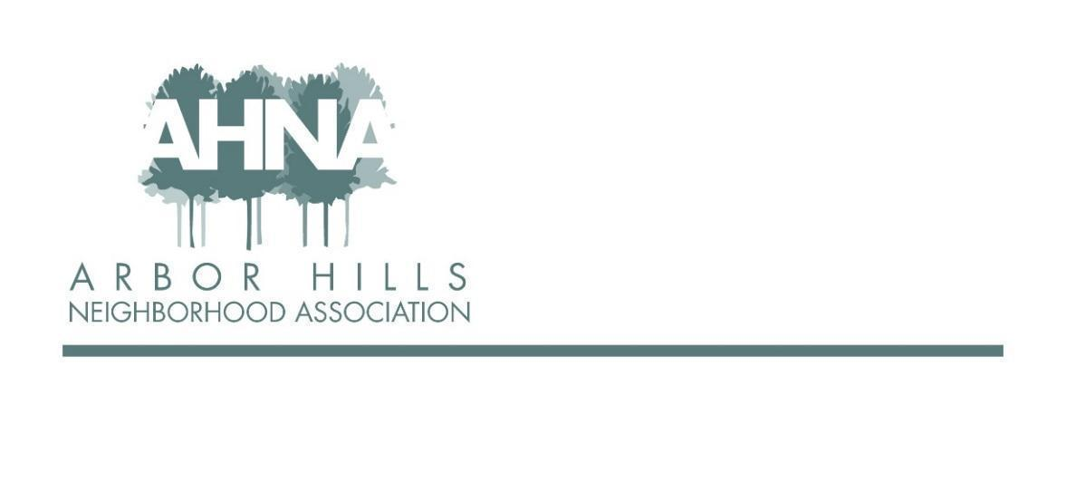
BOARD MEETING
Tuesday, November 9th, 2021
Via Zoom
Meeting starts at 6:30 pm

In attendance: Ashley Gibson, Jackie Cooper, Lisa Fernandez, Nicholas Griffiths, Rebecca Koerschner, Michael Horecki, Dave Makovec, George Ermert, Neil Dinndorf

Absent: Samantha Castro, Grant Roeming, Josh Grotheer, Mary

- Approval of July September meeting minutes, Annual meeting minutes 6:36
& review follow ups —Jackie
  - Action items (September Meeting):
    - Replace signs for Food Truck night; Ashley recommends additional signs for Halloween Night, etc. [Ashley and Neil are planning to order new signs; order has been canceled twice; will get done in 2022]
    - Reorder envelopes for membership [Michael working on the formatting to get quote from printer]
    - Membership list - need to compare to Mailchimp list (Jackie has volunteered to do this - Neil will send information to Jackie as to what is needed, etc.) [Per Rebecca - just add emails to list; Nicholas - could get emails from block captains, will send to Jackie to add; Jackie recommended sending a “welcome to the list” email and making sure people know they can unsubscribe]
    - Under budget on ad revenue, only rec’d from MG&E (Neil will follow up with Josh) [Neil - another has come in, still need to follow up with Josh]
  - Motion to approve Sept minutes, Neil. 2nd from Michael.

- President’s report - Ashley 6:40
- Beers with the Board - complete the poll (will be indoors)
- Christmas Party - George: would the Beers with the Board serve as the neighborhood Christmas/Holiday party? Ashley liked this idea.
- Redistricting - Arbor Hills has been moved from District 14 to District 10 per recent Common Council vote (little time for us to give feedback once we heard about this change); will not move until next election; 3 current alders will be located in new District 10, no existing alder in District 14; Sherri Carter plans to run for District 10, huge advocate for Arbor Hills (former AHNA President)
- Events Coordinator - two members interested; most likely will be co-coordinators; good idea due to large amount of work and number of events
- Training of new members will happen soon
- Newsletter designer has moved out of neighborhood and will continue for next newsletter and possibly next two, but we need to find a new designer;
  - ACTION ITEM: advertise in next newsletter that we are looking for a new designer (Michael)
- Annual meeting follow up - ran well, but low turnout; next year we need to put out signs and advertise much more; Neil - would be nice to have a reception or way for people to mingle/chat before/after; George - not many in attendance who were not on the board - need to be in person to get engagement and memberships.

- Budget - Neil 6:57
  - 2021 members 172, new 19, non-renewal 37 (just short of 175 goal)
    - 2022 membership goal remains the same (175)
  - Balances: Checking $994.35, Savings $7,723.39, PayPal $175.91
  - Budget: running just about right at budget
    - few ad payments outstanding
    - expenses on target
    - net income should be slightly positive
  - Rebecca: Are we doing the holiday lights competition again? (previously, winner got electric bill paid for one month; Neil says budget would allow)
    - ACTION ITEM: Rebecca to create language for this competition to include in newsletter (expect next one mid-December) and send via email (due to late newsletter - just want people to know about it asap); Neil to add to budget
  - Question from George - are we going to get the outstanding ad payments? (Neil emailing Josh for an update); should still have budget for holiday light winner payment if ad payments are received
  - Question from George - grants; our income is not reflective of what we used to have due to an increase in events and does not allow for grants; what can we do? Neil - can we get someone to sponsor events (ex. 4th of July party); Jackie asked about membership levels, George wonders if we increase dues since we have been at $20 for a long time; Nicholas - think a membership push to get more members vs. increasing the membership fee, have “booths” at our events to get more members; Ashley - membership “value”, for example higher member level gets paper copy of newsletter
    - ACTION ITEM: sub committee to look into this in more detail and come back to board with recommendation (before/early 2022) [Mary as Treasurer, Jackie membership list, George - will lead, Nicholas] [Neil will check on numbers of autorenewals and report to sub group; add to invite for first meeting]

- Events - Samantha (absent) 7:16
  - Halloween parade was successful, truck-or-treat only had 1 or 2 vehicles (need to maybe advertise or get more participation) [Photos coming]
    - Neil recommended letting homeowners near park know more about the event
  - Holiday Lights competition
  - Samantha/Ashley Working on next coordinator(s)

- Newsletter - Michael 7:19
  - Newsletters are getting delivered right now
  - Emails sent out for content gathering
  - One large packet (90-100) have not been picked up/delivered
    - Communication committee should meet to discuss this bottleneck and communication going forward
      - ACTION ITEM: communication committee meeting: Michael will lead, Rebecca, Ashley, Lisa

- EOY Wrap-Up/2022 Goal Setting - All 7:23
  - ACTION ITEM: Ashley - send to board poll for meeting time and dates for 2022 meetings
  - Jackie - new website by end of 2022
  - Rebecca - improve communication timeliness regarding events (especially)
  - George - increase membership to 200+
  - Michael - get newsletters out on time, how can we as a neighborhood introduce ourselves to all the political players to make sure we are in the conversations
  - Lisa - see the association make financial donations or grants to organizations or others in our community
  - Dave (“retiring”) - see annual meeting become more of an event like in the past
  - Nicholas - increase membership, 100% distribution of newsletters (last vacant block captain position filled!)
  - Neil (“retiring”) - return and continuation of opportunities for engagement (ice cream socials, block parties, etc.); membership drives at events with Square reader, etc. (people walking around perhaps)
  - Ashley -
    - neighborhood goal: back-to-the-basics - we have a beautiful newsletter, we have a web of block captains, but there is a disconnect; executing better with what we are doing (focus on what we know and do it really really well)
    - board goal: make it fun again (“burger & a beer with neighbors!”), Zoom takes away a lot of the fun stuff; balance convenience of zoom with the benefit of in-person “fun”

- Adjourn (motion, Michael; 2nd, Neil) 7:35

